GOVERNMENT DEGREE COLLEGE, GUMMALAKSHMIPURAM

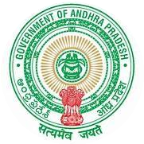

**(Affiliated to ANDHRA UNIVERSITY , VISHAKHAPATNAM)**

An ISO9001:2015 Certified College .

**BEST PRACTICE**

Objectives of the practice:

* To access the information throughout the Globe and to extract extensive knowledge on subject through ICT.
* To implement, analyze, practice a better method of learning to student and using ICT for better communication by presenting in teaching.
* To use ICT Tools for effective utilization of educational resources both in teaching and learning processes.
* To provide the possible solutions to overcome the drawbacks in rural and semi urban areas of Govt. degree colleges and also for providing extra efforts.
* To share the study material among the students and staff.

Context:

Digital transformation of educational resources and communication technologies is a major reason for utilization of ICT and ICT Tools in 21st century. It has incredibly changed the nature of accessing information throughout the Globe. The technology penetrated into the common man’s hand through mobile devices for 24X7 services for enhancement of knowledge.

The ICT (Information and Communication Technology) including not only well equipped ICT class rooms but also e-mails, websites, social networking sites for the purpose of teaching and learning process for accessing student at any time and any place during the pandemic periods too.

The Practice:

The Technology in the class room help educators to get more students for effective involvement, improve practical skill and most importantly make learning fun. The faculty is encouraged to undergo training programmes of MOOCs, MOODLE, ICT tools in teaching and learning process sponsored by Commissioner of Collegiate Education, Andhra Pradesh.

In the effort of self learning, students are also encouraged to prepare presentations using the power point during their seminars.

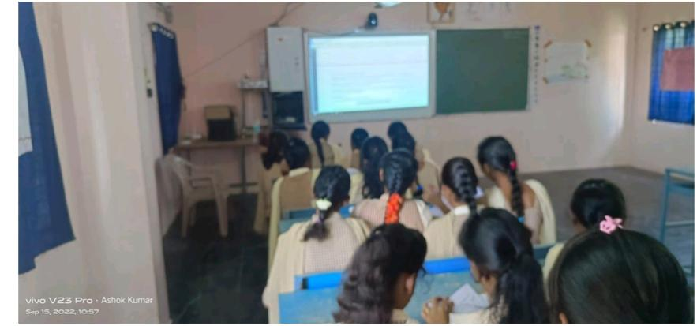

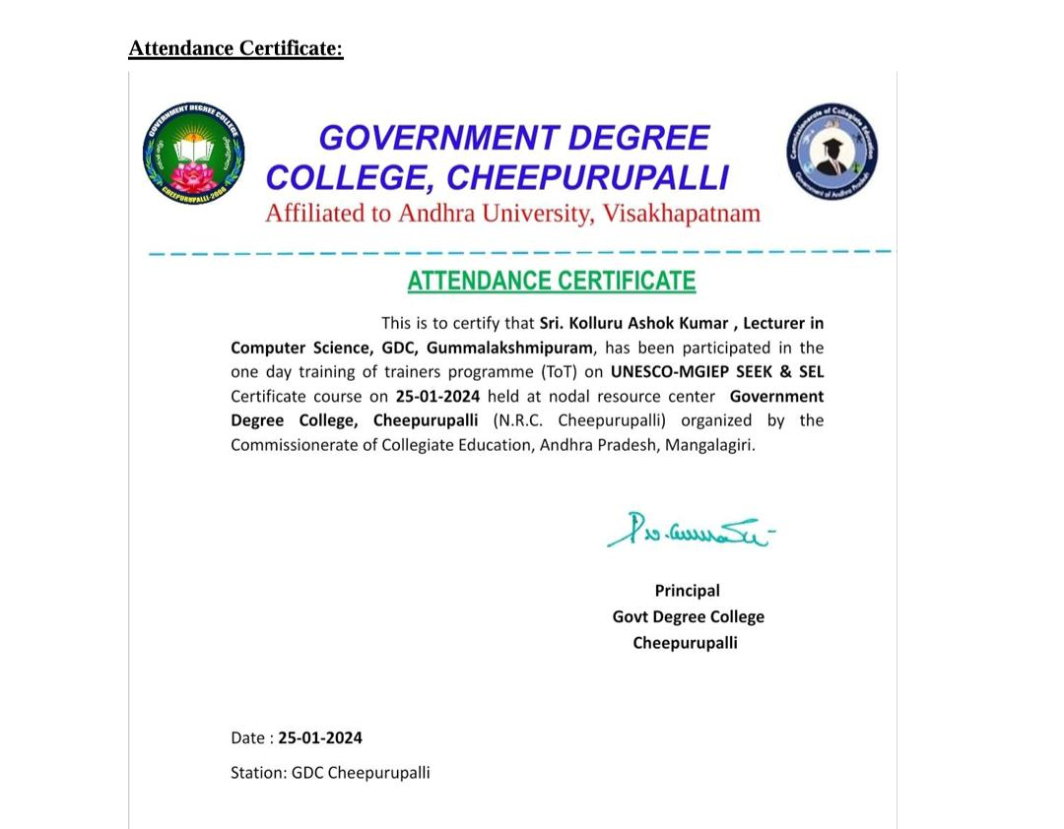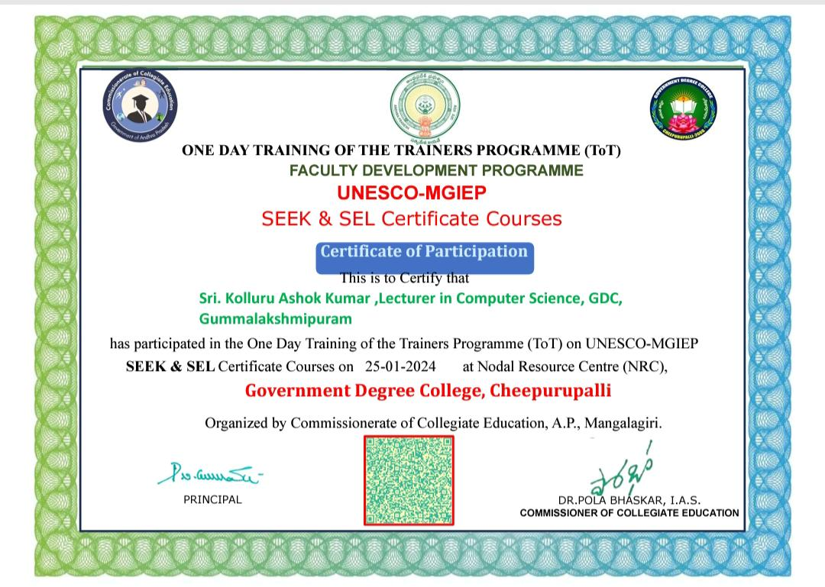

**K Ashok Kumar, Lecturer in Computer Science delivering lecture by using ICT Tools**

**TOT at GDC,Cheepurpalli , one day Training Programme on 25-01-2024**

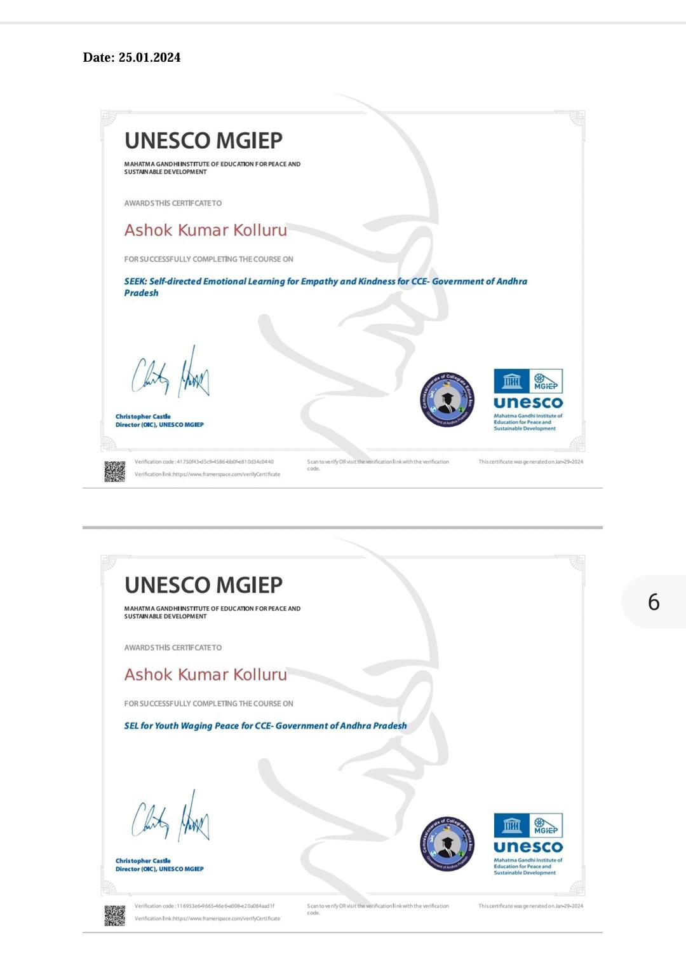



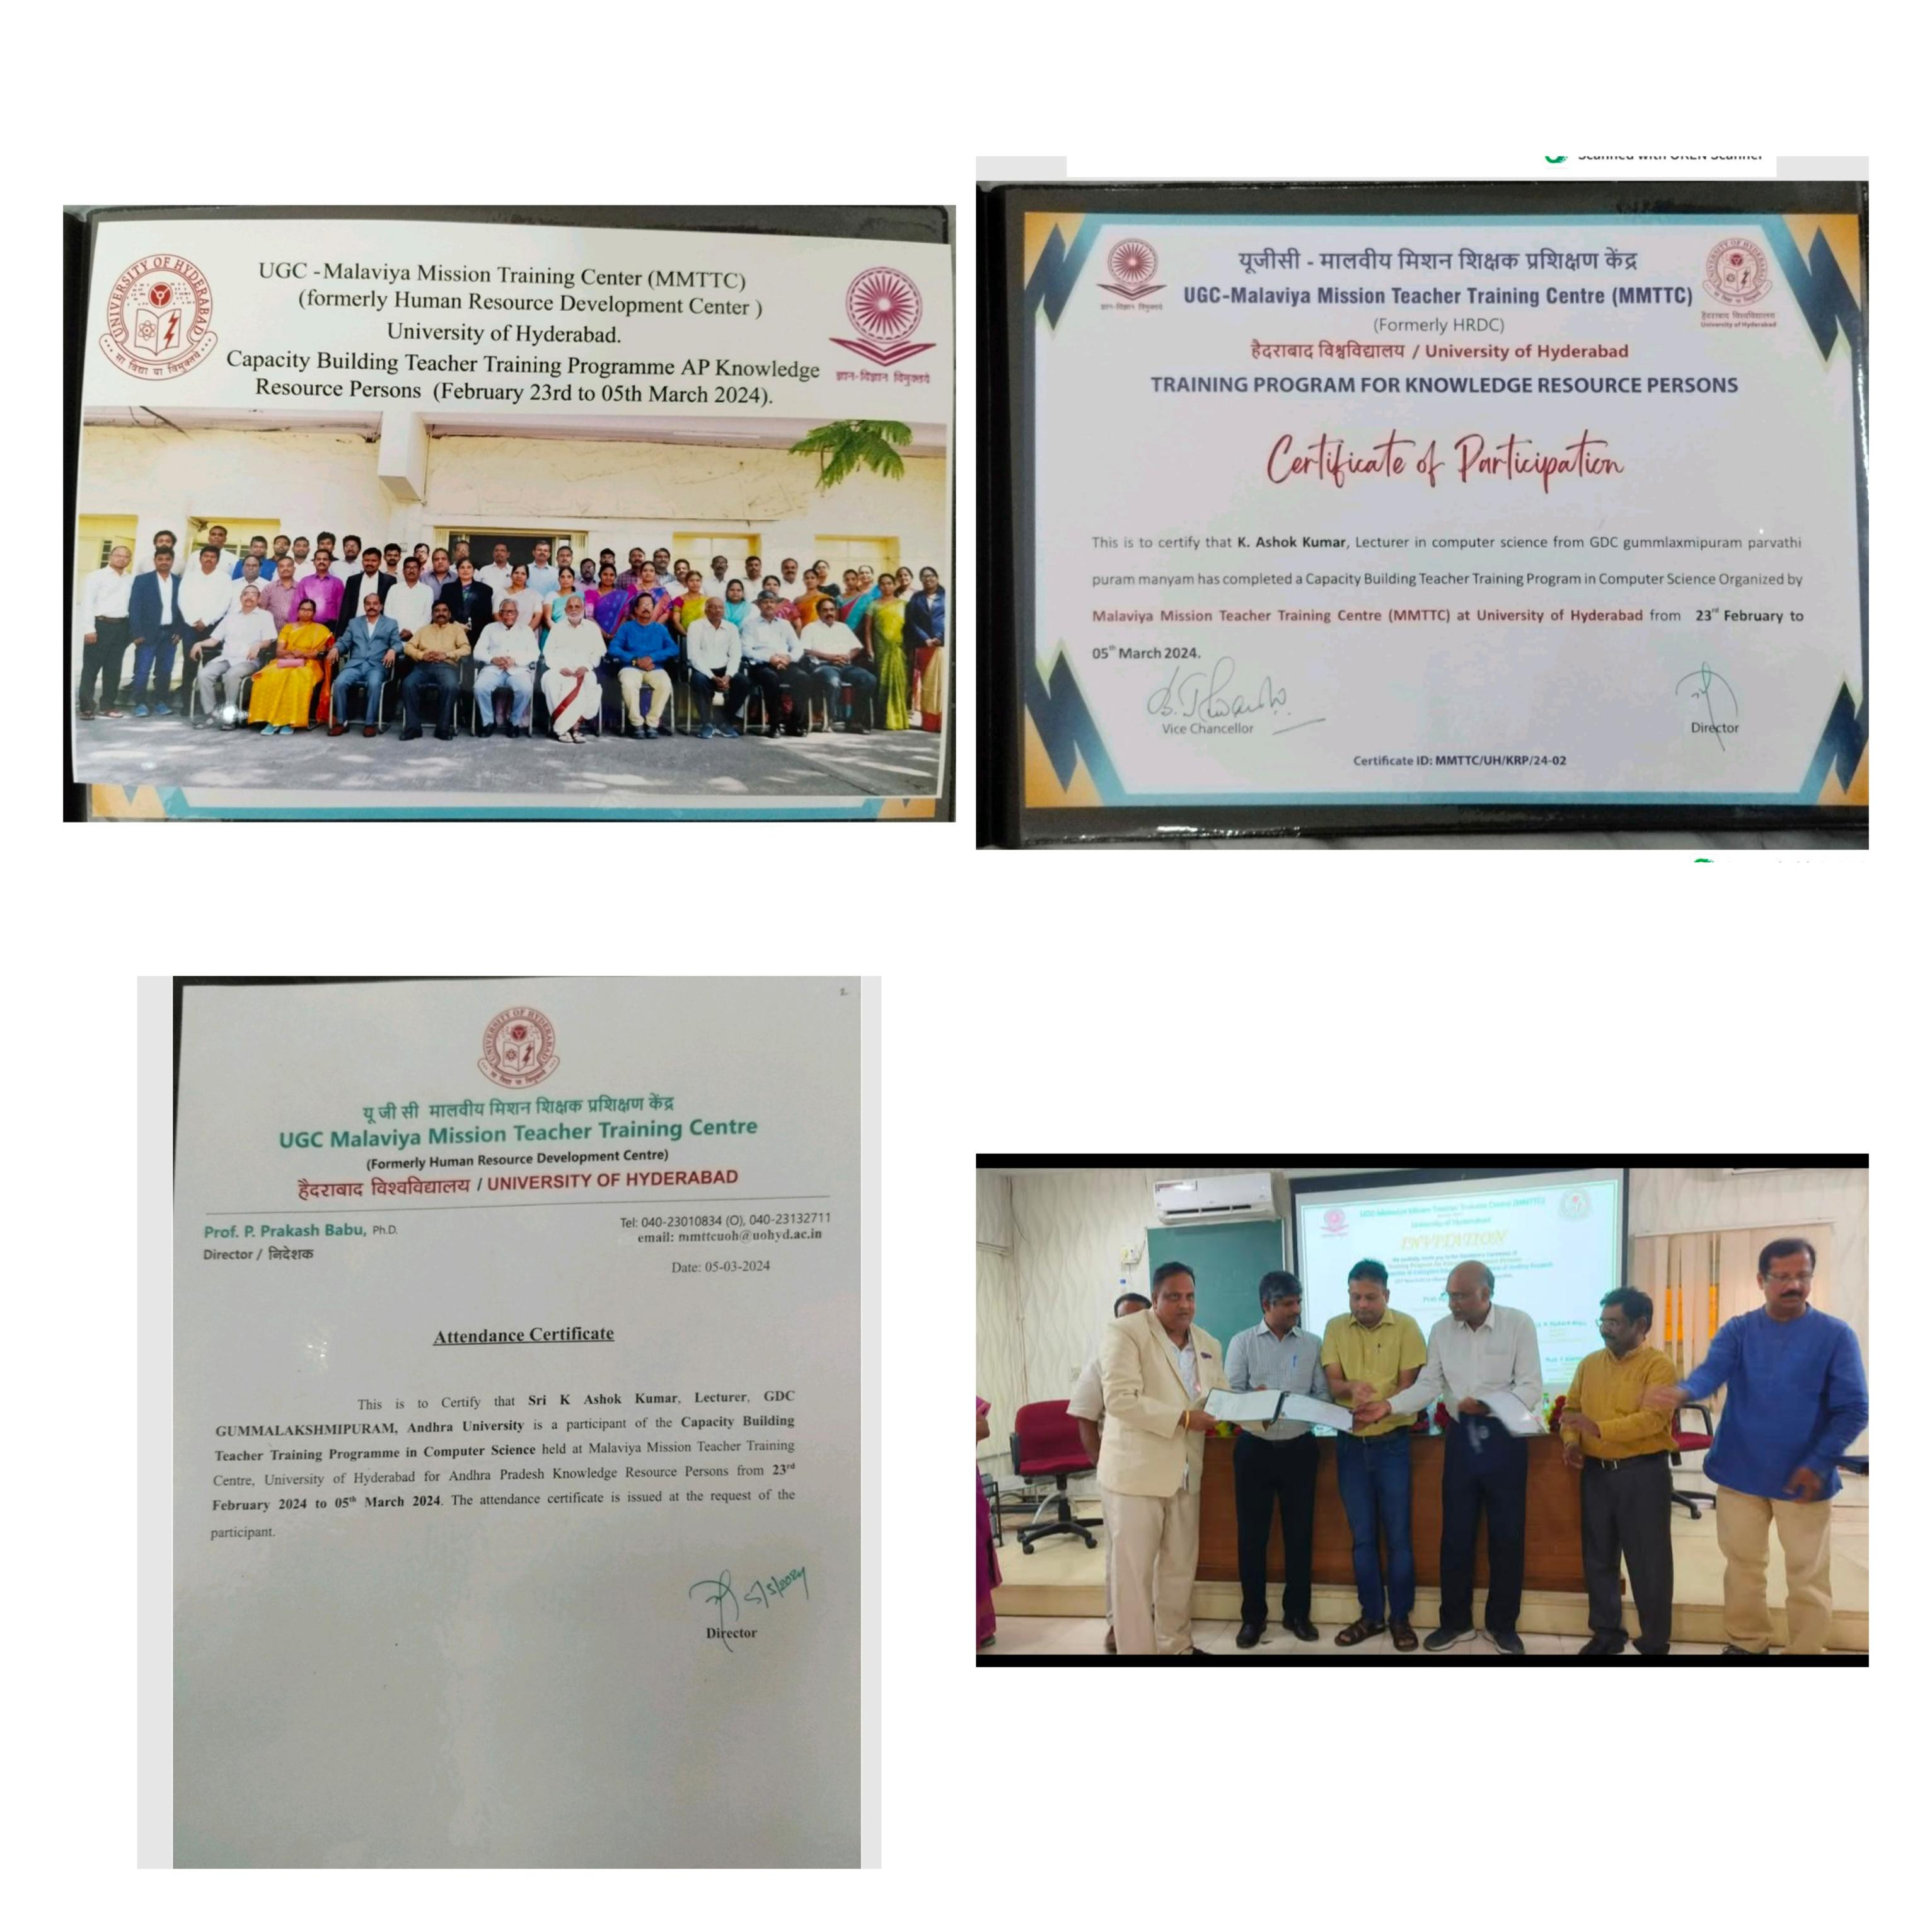

**FDP, Key Resource Persons( KRP) , University of Hyderabad**

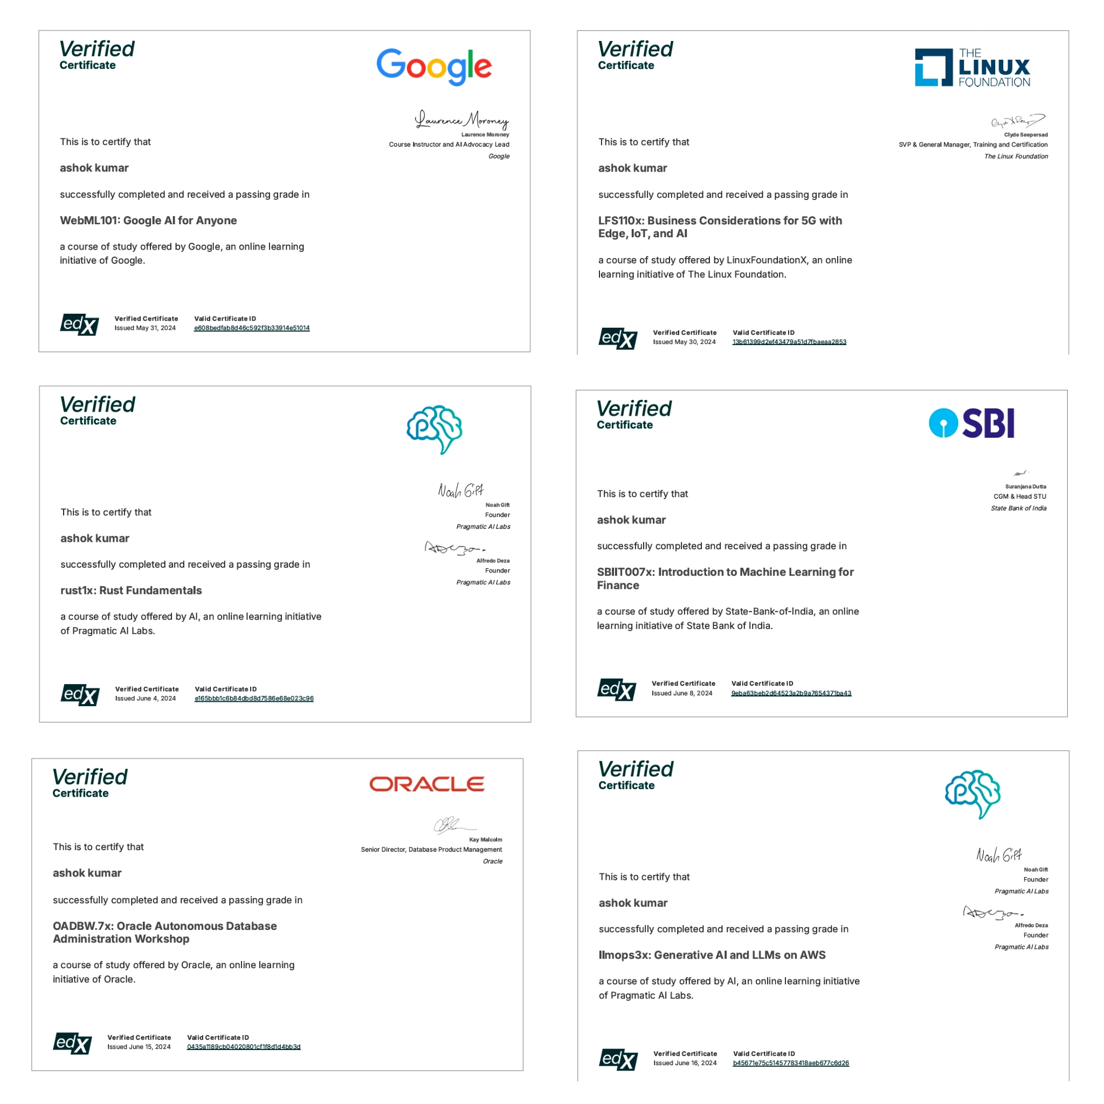

**EDX Certificates of K Ashok Kumar Lecturer in Computer Science**